University of Bejaia
Department of Electrical Engineering
English course

Lecture 02: Engineering, what is it all about?
Objective: At the end of this lecture, students are expected to have a clear idea on different engineering field and to situate themselves.
Read the following text to find out how many engineering branches are mentioned.
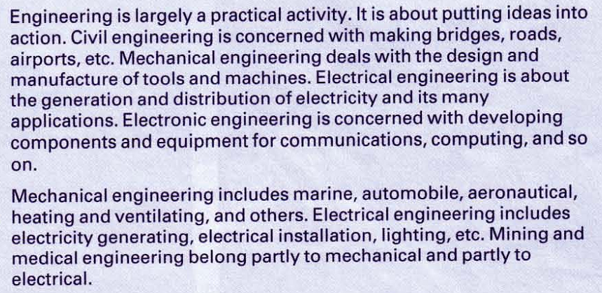

Complete the following diagram according to the previous text
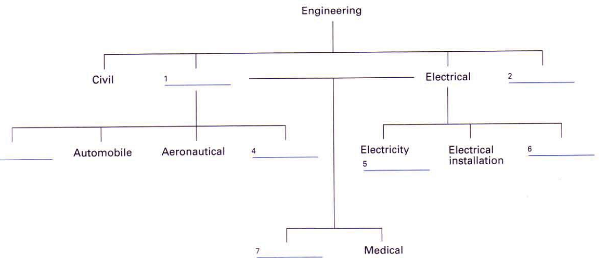

Use the words ‘Deal’ and ‘concern’ to link between columns A and B (describe that link in a small paragraph)
A B
Mechanical Machines
Electrical Electricity
………………………………………………………………………………………………………………………………………………………………………………………………………………………………………………………………………………………………………………………………………………………………………………………………………………………………………………………………………………………
Complete the following sentences
Mechanical engineering………………………..machines
Machines…………………………………………………mechanical engineers

Describe the following diagram in few sentences.





