For many reasons, mainly economic, most of transmission components in power system are AC. However, is it true that economically AC power transmission is better than DC power transmission?
In figure below, a comparison is made for on land AC and DC transmission systems regarding the components cost and transmission losses for the same capacity.
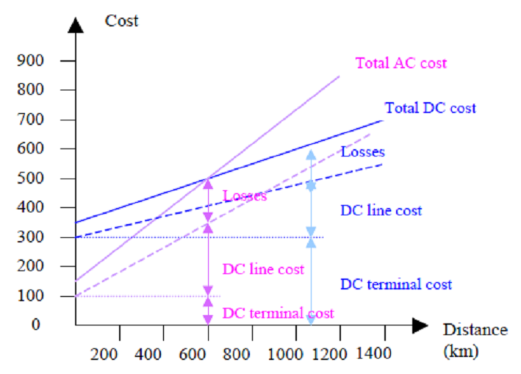
Cost investments:
A HVDC line costs less for the same transmission capacity even when accounting for the conversion stations that are required at both sides of the lines since producers and customers are normally using AC technologies. Considering both factors (investment costs and losses), HVDC lines are economically feasible for distance of about 600-800 km on land and 50 km overseas.
Losses:
If the systems are optimized, losses associated with HVDC transmission lines are lower than those of HVAC lines: 3% per 1,000 km compared with 7% per 1,000 km for a typical ±800 kV line. Losses of a sea HVAC line can reach 60% per 100 km. This statement remains true even when one adds losses associated to converters (about 0.6 % of the transmitted power per station).
Capacity:
HVDC transmission lines have more capacity than the HVAC lines for the same voltage: the maximum capacity of a typical ±800 kV HVDC lines is around 6,400 MW whereas the maximum capacity of a HVAC line is only 2,000 MW
Other considerations:
- HVDC lines consist of a dipole with a positive and a negative line, while HVAC lines consist of three phases and consequently three lines and larger pylons. However, environmental issues of DC are associated with the converter stations: they include audible noise, visual impact, electromagnetic compatibility, and use of ground or sea return path in monopolar operation.
- Asynchronous connection. Due to stability reasons,
- DC systems are the only options for connecting two AC networks and for connecting two networks with different frequencies (50 and 60 Hz).
- Controllability. Control of the active power is easy.
- Limit short circuit currents. The DC systems do not contribute to the short circuit current of the interconnected AC system.

Lecture 5
Power Electronic equipements are used to convert electric power from one form to another and to adapt it for consumption. Power electronic conversions are more efficient than electromecanical conversions used before the development of power electronic devices, Diodes, Thyristors and Transistors.

Figure 1 illustrates the power conversion principle.

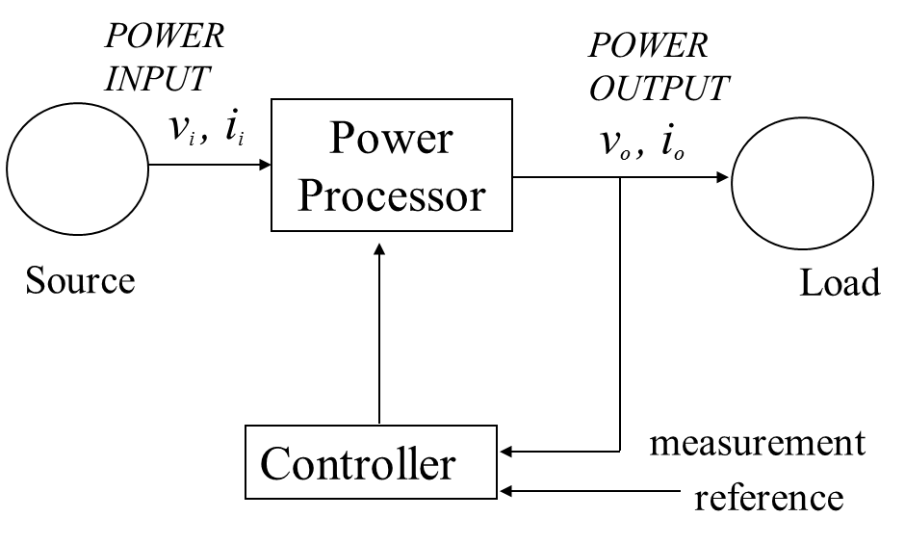

Cite the main parts in this process:
……………………………………………………..
How many conversions are concerned by power electronics ? Cite them
……………………………………………………..
Power electronic converssions are widly used in industrial and domestic applications, some of these applications are illustrated in figures below.

Which conversions are represented in these figures?
……………………………………………………..

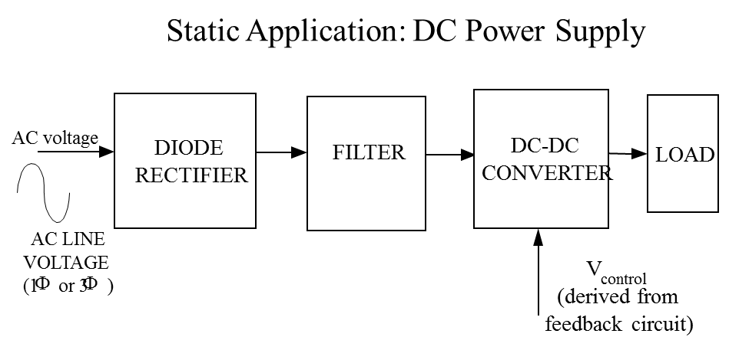
What is the purpose of the filter used figure above?
………………………………………………………………………………………..
What is the purpose of the feedback circuit?
…………………………………………………………………………………………
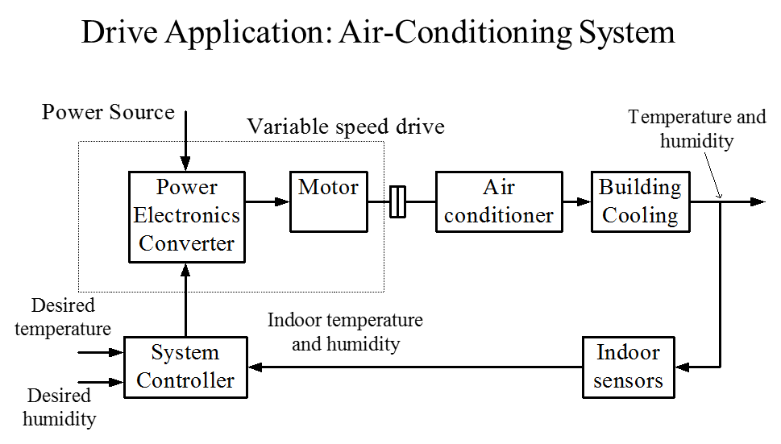
What is the purpose the different components in this process?
…………………………………………………………………………………………………….…………………………………………………………………………………………………………………………………………………………………………………………………………………………………………………………………………………………………

Following a simple single-phase semi-controlled rectifier. Electric waves and control signal are represented with.
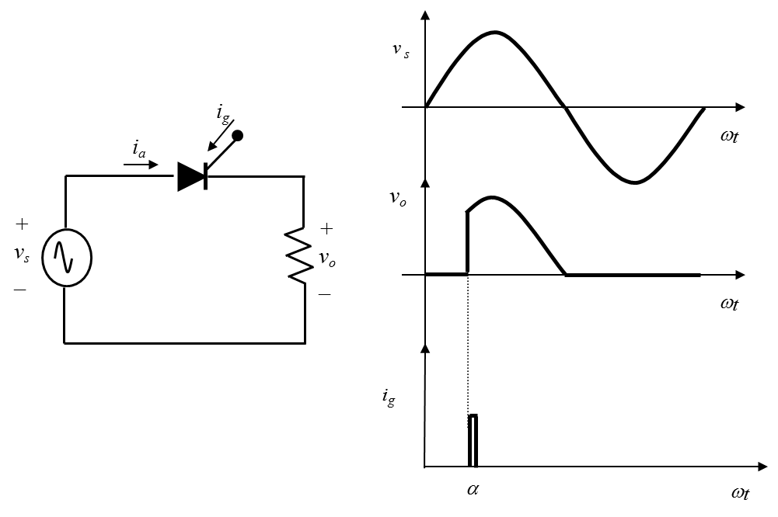
Describe the operation principle of this converter
………………………………………………………………………………………………………………………………………………………………………………………………………………………………………………………………………………………………………..
What do these waves represent?
…………………………………………………………………………………………..
According to these waves, gives the expressions of the average and the rms output voltage
…………………………………………………………………………………………
…………………………………………………………………………………………
What does angle alpha represent?
…………………………………………………………………………………………………………….

Following some power electronic devices widely used industrial applications.
Diode, Thyristor, GTO Thyristor, MOSFET, IGBT.
- Give the complete appellation of abbreviations:
…………………………………………………………………………………………………………..
- Classify these devices regarding the control.
- Give an application example for each device

Lecture 5
Power Electronic equipements are used to convert electric power from one form to another and to adapt it for consumption. Power electronic conversions are more efficient than electromecanical conversions used before the development of power electronic devices, Diodes, Thyristors and Transistors.

Figure 1 illustrates the power conversion principle.

Cite the main parts in this process:
……………………………………………………..
How many conversions are concerned by power electronics ? Cite them
……………………………………………………..
Power electronic converssions are widly used in industrial and domestic applications, some of these applications are illustrated in figures below.

Which conversions are represented in these figures?
……………………………………………………..

What is the purpose of the filter used figure above?
………………………………………………………………………………………..
What is the purpose of the feedback circuit?
…………………………………………………………………………………………
What is the purpose the different components in this process?
…………………………………………………………………………………………………….…………………………………………………………………………………………………………………………………………………………………………………………………………………………………………………………………………………………………

Following a simple single-phase semi-controlled rectifier. Electric waves and control signal are represented with.
Describe the operation principle of this converter
During positive half wave, the thyristor stands blocked until the it is excited by a current is after a time delay corresponding to an angle \alpha=wt. At this time, the thyristor starts conducting and the output voltage is the same as the input one. During the negative half wave the thyristor blocks and therefore the output voltage is zero
What do these waves represent?
…………………………………………………………………………………………..
According to these waves, gives the expressions of the average and the rms output voltage
…………………………………………………………………………………………
…………………………………………………………………………………………
What does angle alpha represent?
…………………………………………………………………………………………………………….

Following some power electronic devices widely used industrial applications.
Diode, Thyristor, GTO Thyristor, MOSFET, IGBT.
- Give the complete appellation of abbreviations:
GTO Thyristor: Gate turn-off thyristor
MOSFET : Metal Oxide Semiconductor Field Effect Transistor
IGBT: Insulated Gate Bipolar Transistor
- Classify these devices regarding the control.
Diode: Uncontrolled power switch
Thyristor: Semi-Controlled power switches
GTO, MOSFET and IGBT: Fully-controlled power switches
Give an application example for each device:
Diodes are used for AC-DC conversions dedicated to small electronic loads like TV, computer, and printer.
Thyristors are used for DC-DC conversions applied to industrial applications like heating and somme power system applications like SVC and STATCOM
GTO Thyristors are widely used in power system application for power flow control (STATCOM, UPFC)
MOSFETs are often used for DC-DC conversions to supply DC motor, MOSFET has very high switching frequency (hundreds of kHz)
IGBTs are used in AC-DC conversions like PWM (pulse width modulation) rectifiers and DC-AC conversions for variable speed drive and also in power system applications like renewable energy conversion and its connection to grid.

