Exercice N° 02 : VHDL et Process
Soit le code VHDL ci-dessous :
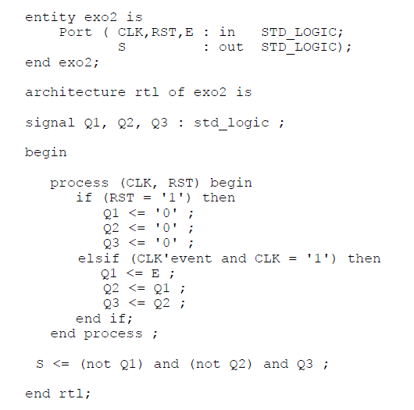
Compléter le chronogramme temporel ci-dessous.
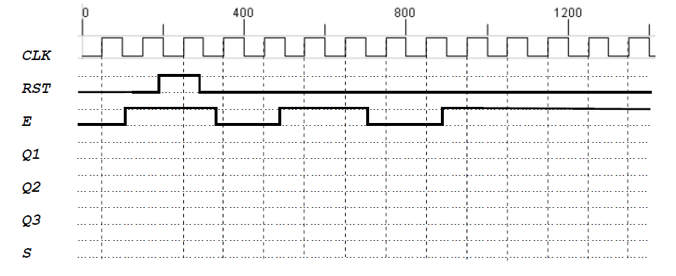
Exercice N° 03 : Code VHDL
La figure ci-dessous représente le schéma logique d’un additionneur à 1 bit, par des portes logiques combinatoires.
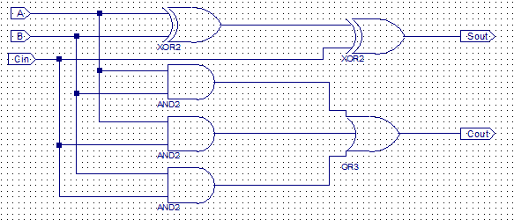
Fig. 1. Schéma d’additionneur implémenté sur logiciel Xilinx de 1 bit.

Donner le code VHDL de circuit ci-dessus.
………………………………………………………………………………………………………………………………………………………………………………………………………………………………………………………………………………………………………………………………………………………………………………………………………………………………………………………………………………………………………………………………………………………………………………………………………………………………………………………………………………………………………………………………………………………………………………………………………………………………………………………………………………………………………………………………………………………………………………………………………………………………………………………………………………………………………………………………………………………………………………………………………………………………………………………………………………………………………………………………………………………………………………………………………………………………………………………………………………………………………………………………………………………………………………………………………………………………………………………………………………………………………………………………………………………………………………………………………………………………………………………………………………………………………………………………………………………………………………………………………………………………………………………………………………………………………………………………………………………………………………………………………………………………………………………………………………………………………………………………………………………………………………………………………………………………………………………………………………………………………………………………………………………………………………………………………………………………………………………………………………………………………………………………………………………………………………………………………………………………………………………………………………………………………………………………………………………………………………………………………………………
Exercice N° 04 : Code VHDL
Soit la description VHDL suivante:
entity exercice2
port ( x1, x2, x3, sel: in std_logic;
y: out std_logic);
end exercice2;
architecturearchi of exercice2 is
signal a, b, c, d, e, f: std_logic;
begin
a <= x1 or x3;
b <= x1 and x3;
c <= x2 and a;
d <= b or c;
e <= x1 xor x2;
f <= x3 xor e;
P1: process (d, f, sel)
begin
ifsel=’0’ then
y <= d;
else
y <= f;
end if;
end process P1;
end architecture archi;
1. Tracez à partir d’éléments de base le schéma correspondant.
2. Le processus P1 est-il combinatoire ou séquentiel? Justifiez.
3. Quel est selon vous la fonction de ce circuit?
………………………………………………………………………………………………………………………………………………………………………………………………………………………………………………………………………………………………………………………………………………………………………………………………………………………………………………………………………………………………………………………………………………………………………………………………………………………………………………………………………………………………………………………………………………………………………………………………………………………………………………………………………………………………………………………………………………………………………………………………………………………………………………………………………………………………………………………………………………………………………………………………………………………………………………………………………………………………………………………………………………………………………………………………………………………………………………………………………………………………………………………………………………………………………………………………………………………………………………………………………………………………………………………………………………………………………………………………………………………………………………………………………………………………………………………………………………………………………………………………………………………………………………………………………………………………………………………………………………………………………………………………………………………………………………………………………………………………………………………………………………………………………………………………………………………………………………………………………………………………………………………………………………………………………………………………………………………………………………………………………………………………………………………………………………………………………………………………………………………………………………………………………………………………………………………………………………………………………………………………………………………………………………………………………………………………………………………………………………………………………………………………………………………………………………………………………………………………………………………………………………………………………………………………………………………………………………………………………………………………………………………………………………………………………………………………………………………………………………………………………………………………………………………………………………………………………………………………………………………………………………………………………………………………………………………………………………………………………………………………………………………………………………………………………………………………………………………………………………………………………………………………………………………
Question 1:Un langage de programmation du matériel comme VHDL :
- Est un 10% d’apprentissage ;
- Est un 100% d’apprentissage ;
- 90% de pratique ;
- 100% de pratique ;
- Aucune des ces réponses.
Question 3: Loi de Moore est la prédiction :
- Du doublement du nombre de transistors ;
- De doublement du surface d’implémentation dans une puce tous les deux ans ;
- De réduction de nombres des transistors dans une puce ;
- Aucune des ces réponses.
Question 4:Réalisation descircuits intégrés par l’approche spécifique et semi-spécifique permettentd’avoir de meilleures performances:
- Vrai ;
- Fausse ;
- Aucune des ces réponses.
Question 5:Implication de la loi de Moore, nous amenons à l’utilisation des circuits :
- Programmable sans mémoire ;
- Spéciale optimiser ;
- Logique séquentielle et combinatoire ;
- Aucune des ces réponses.
Question 6:Un langage VHDL permet de modéliser un systèmeélectronique :
- Sans entrées et sorites ;
- Non modélisable ;
- Sans fonction mathématique ;
- Aucune des ces réponses.
Question 7:A quoi correspondent la simulation comportementale, ………………………………………………………………………………………………………………………………………………………………………….……………………………………………………………………………………………………………………………………………………………………………………………………………………………………………………………………………………………………………………
Question 8:A quoi correspondent la simulation temporelle, ………………………………………………………………………………………………………………………………………………………………………….……………………………………………………………………………………………………………………………………………………………………………………………………………………………………………………………………………………………………………………
Exercice N° 05 : Code VHDL
- Corriger le programme suivant, et Donner le circuit correspondant au même programme ?
libraryie……;
use ieee.std_logic_1164.all;
useieee.std_logic_arith.all;
useieee.std_....._unsigned.all;
ENTITY Compteur IS
PORT (
………………………….IN std_logic;
qs : OUT std_logic_vector(3 downto 0)); ……….. sortie véritable
END Compteur;
ARCHITECTURE aCmpt OF Compteur IS
SIGNAL q : std_logic_vector(……………………..); …………….. signal intermédiaire
BEGIN
…………………….. RAZ synchrone
PROCESS(………) BEGIN
IF …………………………………………………..' THEN
IF raz='1' THEN
q<=(OTHERS=>'0');
ELSE
q <= q + 1;
………………F;
END IF;
END PROCESS;
-- toujours faire :
qs<= q;
END ………………..;

……………………………………………………………………………………………………………………………………………………………………………………………………………………………………………………………………………………………………………………………………………………………………………………………………………………………………………………………………………………………………………………………………………………………………………………………………………………………………………………………………………………………………………………………………………………………………………………………………………………………………………………………………………………………………………………………………………………………………………………………………………………………………………………………………………………………………………………………………………………………………………………………………………………………………………………………………………………………………………………………………………………………………………………………………………………………………………………………………………………………………………………………………………………………………………………………………………………………………………………………………………………………………………………………………………………………………………………………………………………………………………………………………………………………………………………………………………………………………………………………………………………………………………………………………………………………………………………………………………………………………………………………………………………………………………………………………………………………………………………………………………………………………………………………………………………………………………………………………………………………………………………………………………………………………………………………………………………………………………………………………………………………………………………………………………………………………………………………………………………………………………………………………………………………………………………………………………………………………………………………………………………………………………………………………………………………………………………………………………………………………………………………………………………………………………………………………………………………………………………………………………………………………………………………………………………………………………………………………………………………………………………………………………………………………………………………………………………………………………………………………………………………………………………………………………………………………………………

